**Implementing the Factory Method Pattern**

The **Factory Method Pattern** allows you to create objects **without specifying the exact class** of the object that will be created.

**CODE:**

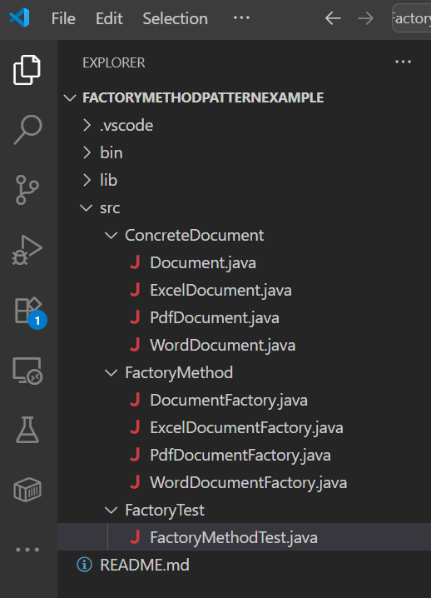

Document.java

package ConcreteDocument;

public interface Document {

void open();

}

ExcelDocument.java

package ConcreteDocument;

public class ExcelDocument implements Document {

@Override

public void open() {

System.out.println("Opening a excel document.");

}

}

PdfDocument.java

package ConcreteDocument;

public class PdfDocument implements Document {

@Override

public void open() {

System.out.println("Opening a pdf document.");

}

}

WordDocument.java

package ConcreteDocument;

public class WordDocument implements Document {

@Override

public void open() {

System.out.println("Opening a word document.");

}

}

DocumentFactory.java

package FactoryMethod;

import ConcreteDocument.Document;

public abstract class DocumentFactory {

public abstract Document createDocument();

}

ExcelDocumentFactory.java

package FactoryMethod;

import ConcreteDocument.Document;

import ConcreteDocument.ExcelDocument;

public class ExcelDocumentFactory extends DocumentFactory {

@Override

public Document createDocument() {

return new ExcelDocument();

}

}

PdfDocumentFactory.java

package FactoryMethod;

import ConcreteDocument.Document;

import ConcreteDocument.PdfDocument;

public class PdfDocumentFactory extends DocumentFactory {

@Override

public Document createDocument() {

return new PdfDocument();

}

}

WordDocumentFactory.java

package FactoryMethod;

import ConcreteDocument.Document;

import ConcreteDocument.WordDocument;

public class WordDocumentFactory extends DocumentFactory {

@Override

public Document createDocument() {

return new WordDocument();

}

}

FactoryMethodTest.java

package FactoryTest;

import ConcreteDocument.Document;

import FactoryMethod.DocumentFactory;

import FactoryMethod.ExcelDocumentFactory;

import FactoryMethod.PdfDocumentFactory;

import FactoryMethod.WordDocumentFactory;

public class FactoryMethodTest {

public static void main(String args[]) {

DocumentFactory excelFactory = new ExcelDocumentFactory();

Document excel = excelFactory.createDocument();

excel.open();

DocumentFactory pdfFactory = new PdfDocumentFactory();

Document pdf = pdfFactory.createDocument();

pdf.open();

DocumentFactory wordFactory = new WordDocumentFactory();

Document word = wordFactory.createDocument();

word.open();

}

}

## **Output :**

